WebDam Instructions
WebDam is a centralized digital asset management system (DAM) that Penn State University Marketing manages, updates, and offers to all Penn State marketing communicators as a resource. Our WebDam photo repository offers access to the latest, high-quality brand photography for use in Penn State marketing materials. Whether you're in need of general classroom photos or campus beauty shots, you’ll find a wide range of original photography featuring Penn State students, faculty, and staff from colleges and campuses throughout the Commonwealth.

Registering
You must be an approved registered user to access and download images from WebDam.

To register
Go to https://pennst.webdamdb.com/splash.php and click on the word “register” under the blue “login” button. While registering, use your Penn State email and fill out the fields marked in the image below. Click "save." Once you’ve registered, you will receive an email confirmation once your account has been approved by an administrator.
WEBDAM INSTRUCTIONS | PAGE 1
0
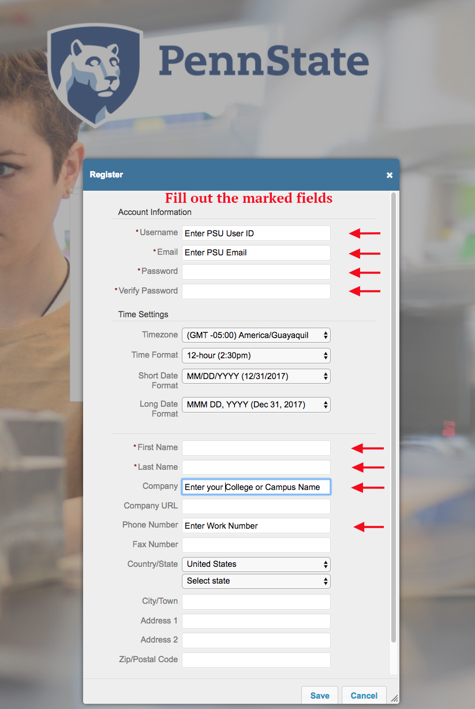
WEBDAM INSTRUCTIONS | PAGE 2
0

Getting Started
WebDam has a very user-friendly interface. Simply click on a featured album on the homepage to discover the latest images or click “assets” on the upper left-hand navigation to search the entire repository.

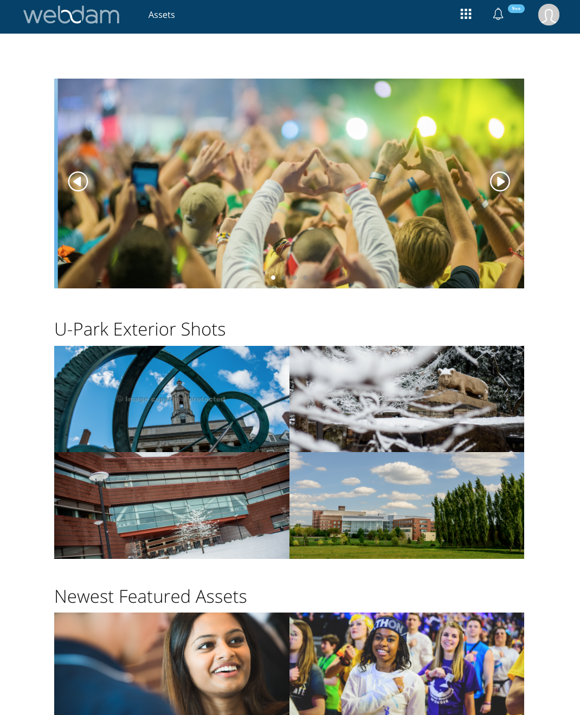

WEBDAM INSTRUCTIONS | PAGE 3
0

Downloading
WebDam allows downloading of single images or several at once.

To download a single image:
- Click on an image you’d like to download.
- A small window displaying the image will pop up.
- In the upper left-hand corner, click on the blue "download" button.
- The original image size is very large, so you may want to use the "custom" sizing preset under the "desired preset" dropdown menu.

To download multiple photos:
- Press and hold shift to select multiple images.
- Press the "download" button in the upper left-hand corner.
- The original image size is very large, so you may want to use the "custom" sizing preset under the "desired preset" dropdown menu.

Setting the custom size:
- Choose "custom" from the "desired preset" dropdown menu.
- Choose the file format you’d like. The most common is .jpeg.
- The resolution should be 200–300 dpi for print materials.
- Dimensions should be 2000 pixels (10 inches) on the widest side.
- Choose the appropriate color mode for the medium for which you're designing. The last page of our element guidelines PDFs includes more information about CMYK and RGB color modes.
- Click "submit."
WEBDAM INSTRUCTIONS | PAGE 4
0
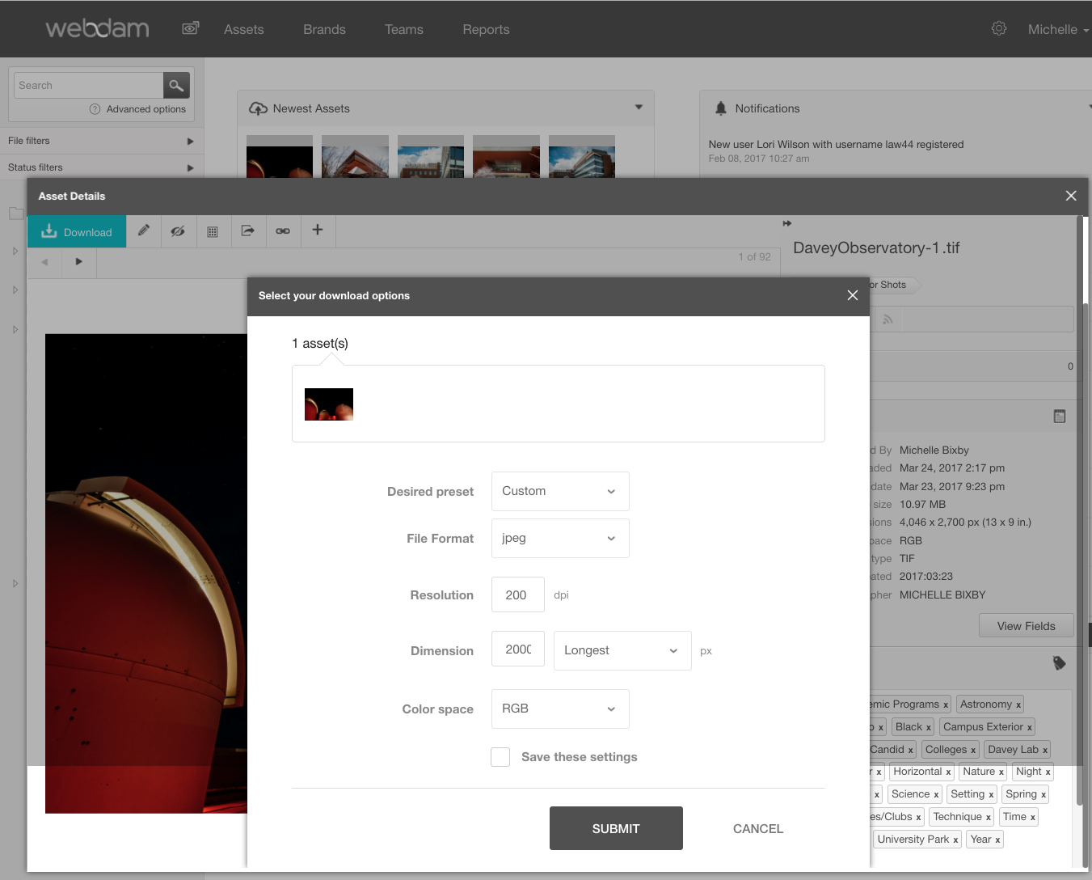

Keywords
University Marketing has an extensive keyword list which helps make searching images in the repository easy.

A list of the most used keywords can be found on the left-hand panel on the “Assets” page. Click “more” to expand the full list.
WEBDAM INSTRUCTIONS | PAGE 5
0
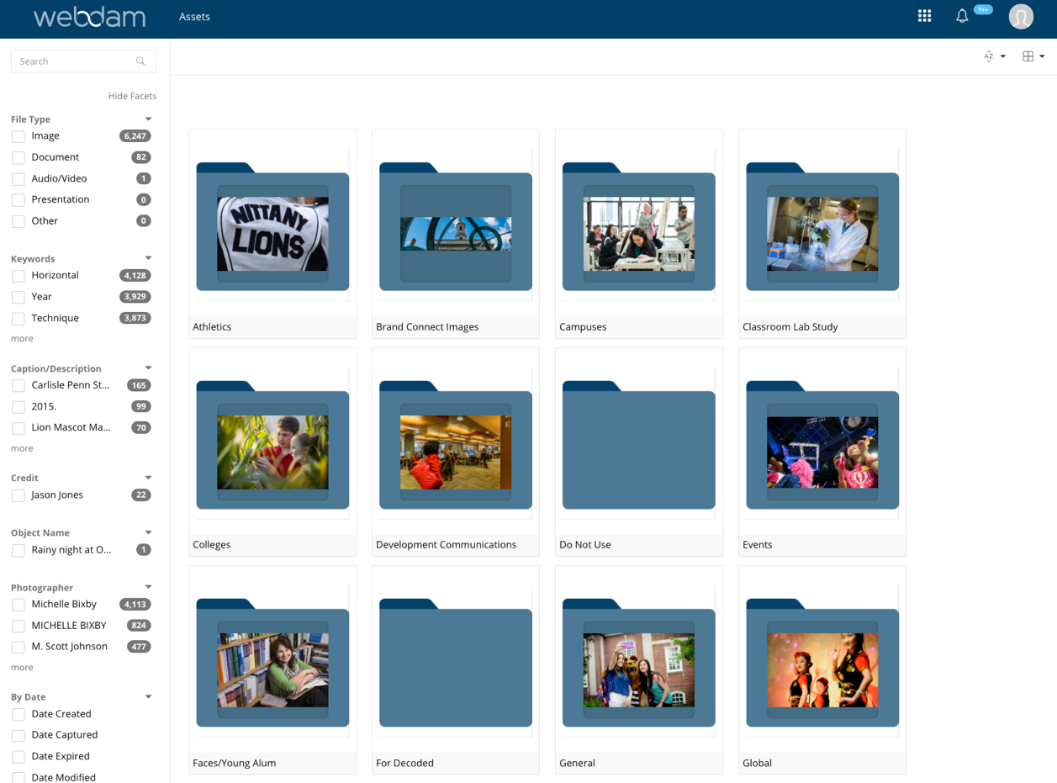

WEBDAM INSTRUCTIONS | PAGE 6
0
brand.psu.edu
Penn State is an equal opportunity, affirmative action employer, and is committed to providing employment opportunities to all qualified applicants without regard to race, color, religion, age, sex, sexual orientation, gender identity, national origin, disability, or protected veteran status.
THIS PUBLICATION IS AVAILABLE IN ALTERNATIVE MEDIA ON REQUEST.
Produced by the Penn State Department of University Marketing U.Ed. SCM 18-58
PHOTOGRAPHY FIELD GUIDE | PAGE 2

