Editing a Pod Cast in GarageBand
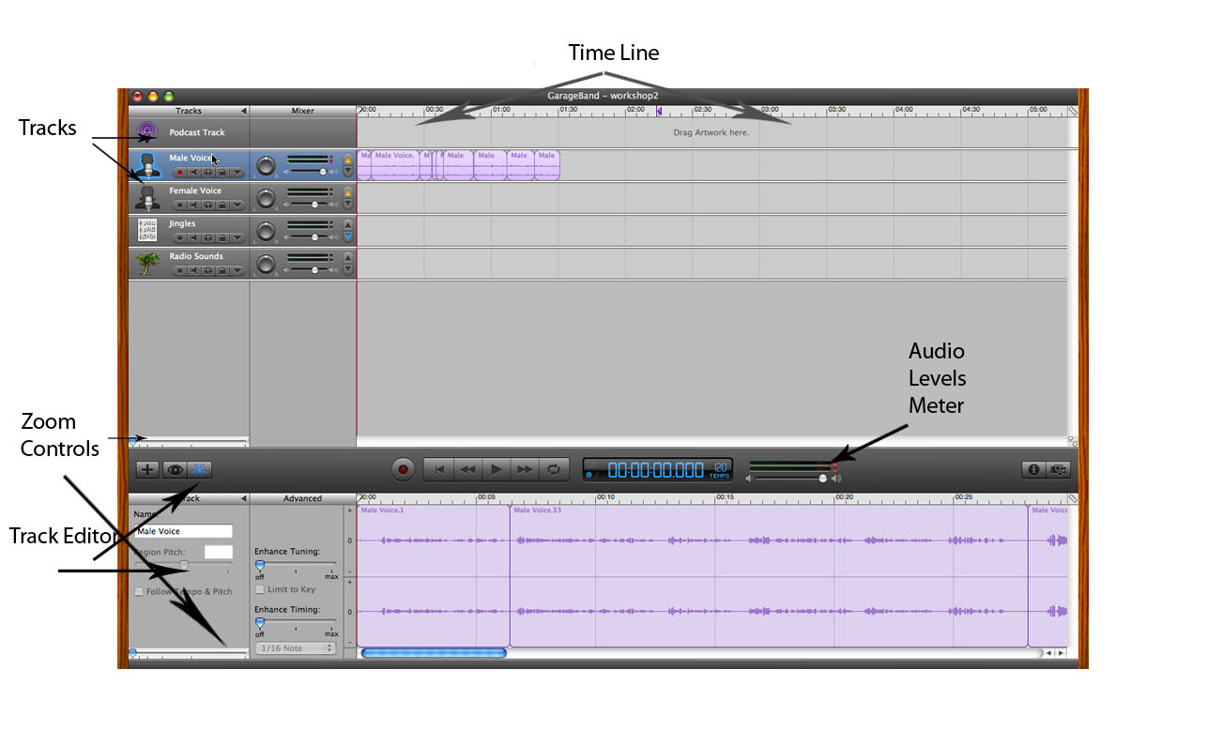

Time Line: The time line is a visual representation of the audio waveform over time.
Tracks: Tracks are layers of audio kept separately for organizational purposes. Stereo audio is mixed down to two tracks a Left and Right Channel.
Zoom Controls: The zoom controls allow us to expand or zoom in/out the timeline or track editor. This can be useful when making edits to bunched up audio.
Track Editor: The track Editor is a close up view of the track you are working on. This allows us to see more of the waveform for specific audio editing.
Audio Level Meter: The audio level meter shows us how loud the audio is that’s being recorded or playing back. If this audio hits the red button it means that the audio has peaked. Audio can be distorted if peaked.

Using the Microphones and M-Audio Box
This section is for following along with the speaker, there is not enough equipment to have everyone in the group record their own PodCast’s so one is being provided for you.
When using the M-Audio Box with microphones to record a PodCast there are a few steps that must be taken before use.

- Make sure that the Phantom Power switch on the M-Audio Box is turned on and the red light beside it is lit up.
- Check to make sure the channel one and channel two volume levers are at mid range.
- Now we must setup the mac to accept input from the M-Audio box, to do this goto System Preferences
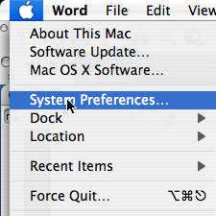
Then click the “Sound” icon 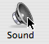 , here you will goto the input tab and choose “Mobile Pre USB” The input volume should be set to about 70% (We can further adjust the volume using the M-Audio Box Volume Levers)
- Now we have to setup the Microphone in GarageBand, open GarageBand and go to preferences then click the “Audio/Midi” Tab and set your “Audio Input” to “Mobile Pre”
- Now you are ready to record audio in GarageBand. (Tip: If you are the only person speaking in your PodCast Set both Microphones up in front of you two get a stereo effect)

Pod Cast Script
Welcome my name is Justin Miller and today we are going to learn how to do a Pod Cast in GarageBand. Let’s start by understand that there will be mistakes in this Pod Cast which will allow you to practice editing in GarageBand to fix these mistakes. As a reminder there are tutorials about Pod Casting available at the digital commons website. That website is digitalcommons.psu.edu. Now lets go ahead and get started with our Pod Cast.

Lets talk about audio tracks, when you have GarageBand open you will see several tracks laid out. This is the Male Voice Track; this track is optimized for recording of the Male Voice. There is the female voice track, which as you guessed it is optimized for the female voice.

Now these tracks aren’t going to really change how your voice sounds they are only an optimization for the vocal ranges that are normally associated with Male and female voices. If you’re recording both male and female voices on the same track then it doesn’t matter which of the two tracks you decide to use.

Well we don’t want to make this Pod Cast too long so I am going to sign off now. If you require any further help please visit our website at digitalcommons.psu.edu or email us at digitalcommons@psu.edu. Adios and have a great day.

Editing your Pod Cast in GarageBand
We want to start by listening to our pod cast to gain an understanding of where mistakes were made.

Now that we have listened to the pod cast we now know there are plenty of mistakes to be edited. To start lets pull out all of the bad audio that we no longer want.

- When opening GarageBand make sure that the view track editor is turned on
- Starting at the Beginning of the pod cast locate the first mistake. That mistake is located about seven seconds into the Pod Cast when I am trying to say “Lets start by understanding”
- Set your play head to the end of your good audio just before the mistake happens. Then you want to click Edit > Split or “command T” On the keyboard. Doing this will make a split in the audio so you are now left with two different pieces of audio in the track.
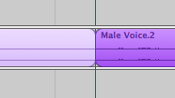
Now we want to split the audio again after the mistake before the good audio that want to keep starts. To do this again position your play head at the end of the bad audio and click Edit > Split
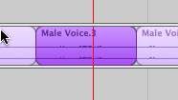
Now you can see we have three sections of Audio the middle one can now be highlighted by clicking anywhere in your timeline to deselect the audio and then clicking on the section of audio you want to use.
Now you can click the delete key to remove the bad audio.
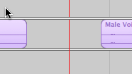
Here we are left with an empty space between our good audio, we can simply click and drag the right audio section and butt it up against the left one.
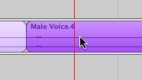
You can now listen to that section of the Pod Cast and hear that the bad audio is removed.

- Now lets go ahead and apply the same method to deleting all of the mistakes, follow the script to understand what I am trying to say and delete all of the mistakes in the audio. Further mistake placement can be found below.

- Mistakes can be found at the beginning of the second paragraph on the script “Lets talk about audio tracks” The third attempt is the one we want to keep.

- After that there is a mistake at the “you’ll see several tracks laid out” line. We want to keep the first one and delete the second line attempt.

- The next error involves mispronouncing the word “specifically” we want to delete the entire first attempt “This track is optimized specifically” and keep the second attempt.

- The next error is found when I tried to say “There is also a female voice track” It took me three attempts to get this out right, keep the third and delete the others.

- The next edit involves a pop that we want to remove that is located just before the line “Now these tracks aren’t necessarily…”

- Our next edit comes when I say “Um” this sounds bad and we want to remove it, the very next line “if your going to record” was bad too so lets remove it.

- The next edit comes when I mess up the line “If you require any further help” Delete the first attempt and use the second.

- Finally there is a pop at the end of the Pod Cast that we want to remove.

Adding Jingles or Intro’s and Outro’s to Our Pod Casts
Adding music at the beginning and end of your pod cast is an easy process when using music already created for this purpose. Provided in this tutorial is a file we can use for both an intro and outro. This file and more can be found under iTunes U in the Penn State Assets Section at the bottom right hand side of the iTunes U home page.

- First we want to zoom out our timeline to give us an overview of the entire podcast, to do so simply click the Zoom out Control and drag it to the left. (refer to the front page to see where the zoom controls are)
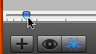
- We are going to start by dragging the PSUintro5.mp3 file found on the desktop right into GarageBand, place the file over the jingles track and drop it.
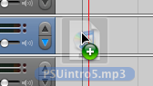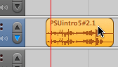
- Next we are going to drag the audio to the beginning of our timeline so that it starts right away.
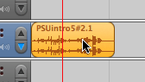
- Now we need to select and drag all of our recorded pod cast audio back away from the beginning a few seconds so we can start the Pod Cast with some music. To do this first select your audio by clicking in an empty space in your “Voice Track” and holding the mouse button down to drag the selection over all of the voice audio.
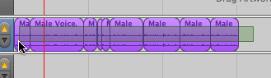
Then simply click on the audio and drag it a few seconds from the beginning.
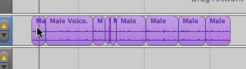
- Now your timeline should look something like this.
- Now if we listen to our pod cast we notice that the music gets lower in volume automatically whenever I start talking. This is because of Ducking, ducking is when the track is setup in GarageBand to automatically lower in volume when the audio of another track begins. If you notice the blue down arrow on the jingles track sets that track to Duck under specified tracks with the up arrow.
- Now we are going to add an outro using the same music for the end of the pod cast. To do so drag the PSUintro5.mp3 file on the Desktop on the end of the jingles track. So that your timeline looks something like this

- After listening to the pod cast again we see that the music seems to long we should shorten it to make it sound better. We will adjust the volume to make the music fade in and out. To do so click the “Show track volume” button on the jingles track.
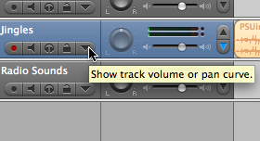
- Now we want to place curves or “key frames” on the track volume line. To do so simply click on the line to add a dot. We want two dots on at the start of the first fade out and one at the end, Then for the outro a dot where the fade in begins and one where it ends. It should look something like this.
- Now we want to lower the volume for the fade out. Click and hold on the third button in and drag the dot to the bottom of the track.

- Now click the fourth dot in and drag it to the bottom of the track.
- Now if you listen to the Pod Cast you’ll notice that the intro fades out and the outro fades in. Congratulations we have completed editing our pod cast. Now we can export our Pod Cast.

Exporting Your Pod Cast
There are several options in GarageBand to export your Pod Cast; we will be using the “Export to Disk” Option.

- To export your Pod Cast Simply Click (Across the top) Share > Export Pod Cast to Disk
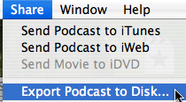
- Now simply Name your Pod Cast, choose where to save it, and then click save.

